Game Description :

Game Rules:
1-

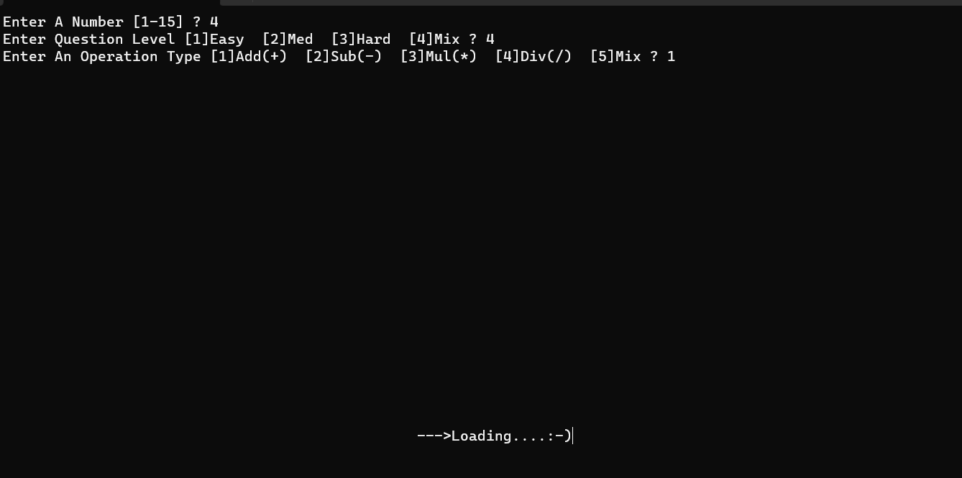

2-Then I Printed Number Of Questions *One By One*
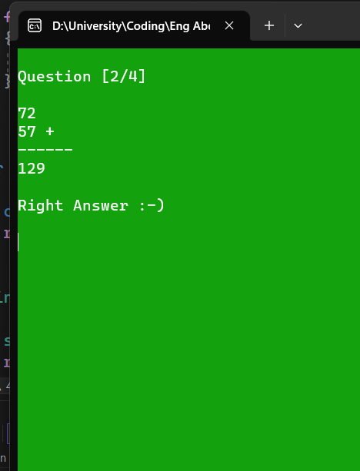

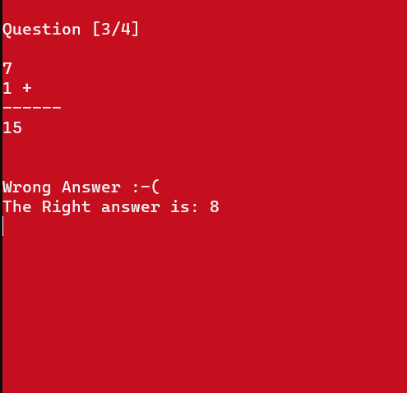

3- Printing The Final Result

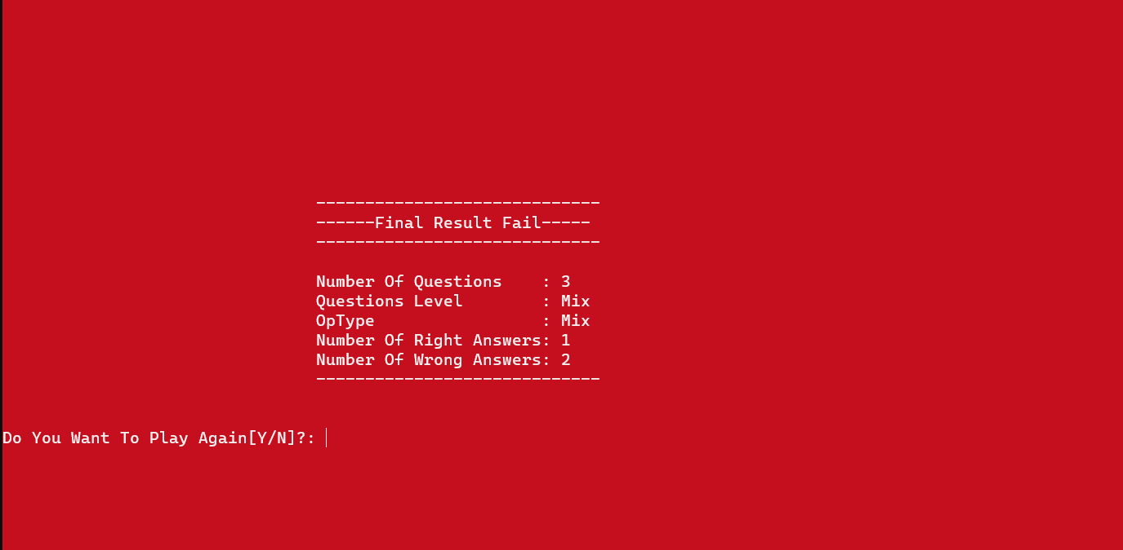

Here I Lost So The BackGround Color Turned To Red
If I Won The BackGround Color would Be Green

